**Pass Task 8.1: BattleShip Sprint 2**

**Meeting Agenda**

Date/Location: 2-May-2019 at 2:00PM in A302

**Information Updates/Reminders**

* Last week was about adding the extensions and documenting the code
* This week we will do a sprint review of our product and process and also continue adding in any extensions or game bugs that are not done yet
* Help from an external consultant has been provided to help get the code converted and working if that was not done.
* Everyone should have used toggl.com to track their time last week. Also track time on tasks this week with Toggl.
* Tutor must be added to GitHub, Trello and Toggl.
* Slack will be used to show the changes in the Trello board during the sprint of activity
* The Programming Help Desk ATC620 is *still* available to help us with programming for this unit.

**Decisions Needed**

* Code in new extensions to further improve on the game
* Repair some issues that might occur from adding extension
* Improving on the overall user interface

**General Items**

* The Trello board needs to be updated ready for the planned Sprint process. In particular columns for project backlog and sprint backlog will be needed.
* Create and link the team slack so that we can be notified and have a nice record of the Trello updates.
* The project backlog of tasks needs to be created. Use the existing bugs and features we have documented, and convert to the required format. Need a meeting after this meeting to get that done and into Trello (today).
* Project backlog tasks need to be prioritised and their time estimated using 1,2,4,8 hour categories. (Today)
* The new Sprint backlog needs to be pre-selected ready for discussion and approval with the project owner. (Today)
* Once Sprint has started, hold a daily scrum meeting. (Start next week?)
* New extensions will need to be implemented

**Meeting Minutes**

Date/Location: 2/5/19 at Swinburne University of Technology in A302

Attendees: Marc Chai, Lim Jia Lok, Aldalton Choo

Start Time: [2:00 p.m.]

End Time: [3:30 p.m.]

**Decisions**

* AC will implementing new background music
* AC will try to implement a new menu background image
* LL will add instruction page
* LL will change ship images
* MC will make the high score UI look better

**Actions**

* 8-5-19 AC should be done implementing a new background music to improve on the user experience when playing the game
* 8-5-19 AC will implement new menu background image to improve on the aesthetic of the menu
* 8-5-19 LL will add an instruction page to help the user understand how to play the game
* 8-5-19 LL will change the ship images to a more realistic one to help improve the look of the ship
* 8-5-19 MC will improve on the high score UI to include options to cycle from easy, medium, and hard mode scores and also the background image to improve visibility.

**Scrum meeting**

Scrum meeting 2nd of May 2019



Figure (1) Scrum meeting 13

I changed the background image and music of the main menu by replacing the image file and music file respectively with the image and song that I wanted. The figure below is an example of the main menu with a new background image

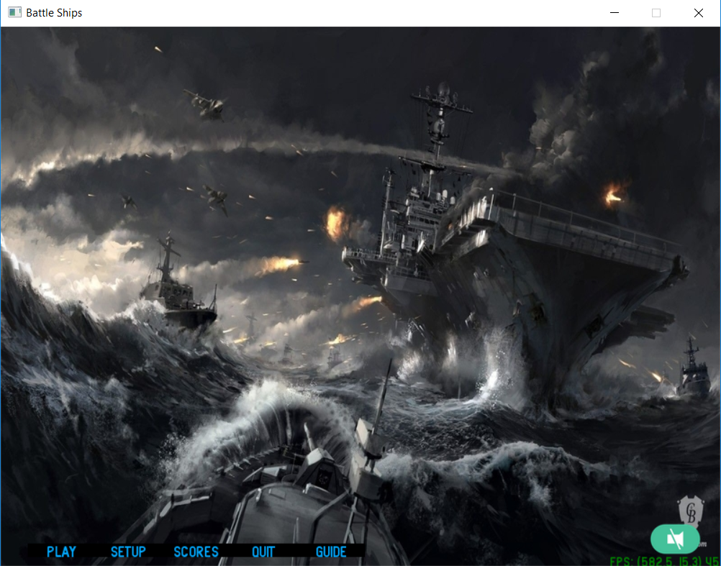

Figure (2) background image of the main menu after changing

Scrum meeting 3rd of May 2019

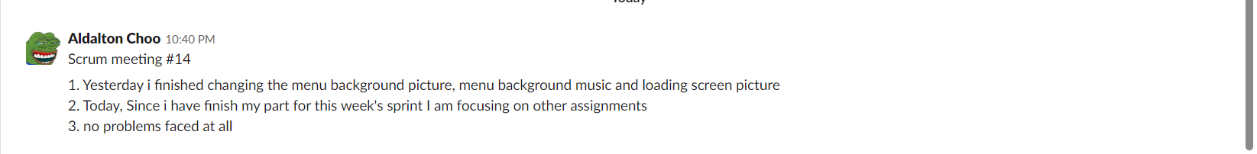

Figure (3) Scrum meeting 14

Scrum meeting 4th of May 2019

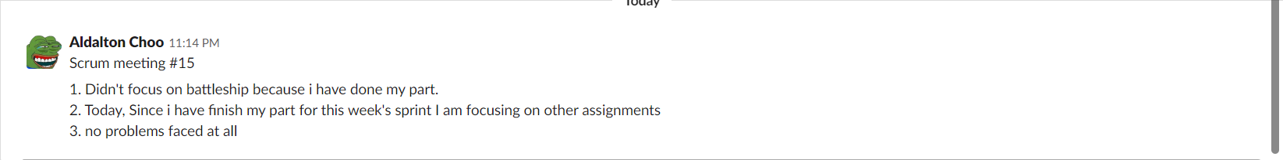

Figure (4) Scrum meeting 15

Scrum meeting 6th of May 2019



Figure (5) Scrum meeting 16

Scrum meeting 7th of May 2019

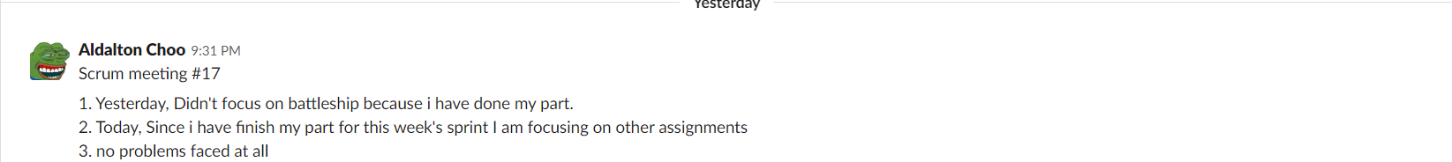

Figure (6) Scrum meeting 17

Trello Board:

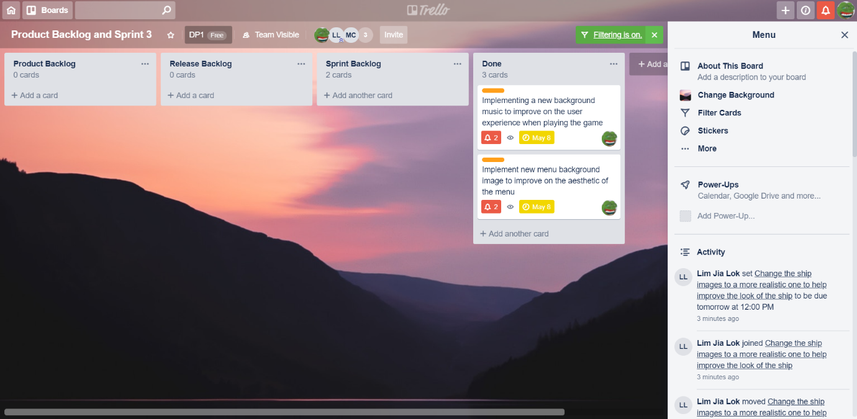

Figure (7) Trello Board

Toggl Board:

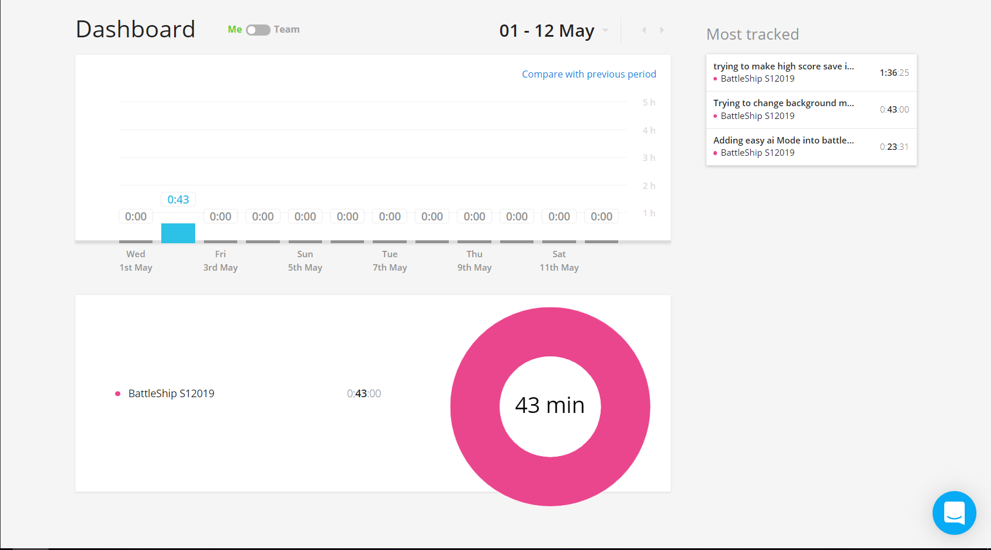

Figure (8) Toggl Board

Git-Hub Contribution graph:

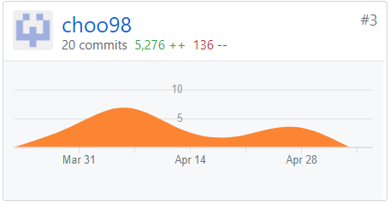

Figure (9) Contribution graph

Git-Hub Network graph:

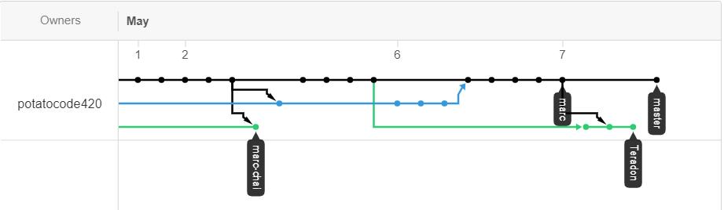

Figure (10) Network graph